**Bug Report**

**Date:**05-10-2024

**Tested By:** Aparna N Kartha

| **Platform** | **Browser** |
| --- | --- |
| Windows 10 | Chrome, Edge |
| Android 14 | Chrome, Samsung Internet |
| Android 13 | Chrome, Samsung Internet |

| **Web Detected** | **How Detected** | **Status** |
| --- | --- | --- |
| Aparna N Kartha | Manual Testing | Open |

| **Feature** | **Bug ID** | **Bug Summary** | **Bug Description** | **Steps** | **Expected Behavior** | **Actual Behavior** | **Attachments** | **Severity/Priority** | **Comments** |
| --- | --- | --- | --- | --- | --- | --- | --- | --- | --- |
| Functional Bug | B_001 | The studio button directs to a white blank page. | When click on the studio button it directs to a blank white page. It does not give any relevant data. | 1. Visit the URL<https://server-swimmers-035.vercel.app/> 2. Click on the studio button. 3. Check whether the studio button directs to the relevant page. | The studio button directs to the relevant page with data. | The studio button directs to a white blank page. | Screenshot | High | This issue is affecting the user experience |
| Functionality Bug | B_002 | The login button directs to an error page | When click on the login button it directs to an error page. It does not go to login page | 1. Visit the URL<https://server-swimmers-035.vercel.app/> 2. Click on the login button 3. Check whether the login button directs to the login page | The login button directs to the login page | The login button directs to an error page | Screenshot | High | This issue is affecting the user login and user experience |
| Functionality Bug | B_003 | The signup button directs to an error page | When click on the signup button it directs to an error page. It does not go to the signup page | 1. Visit the URL<https://server-swimmers-035.vercel.app/> 2. Click on the signup button 3. Check whether the Sign-Up button directs to the signup page properly or not | The signup button directs to the login page | The sign up button directs to an error page | Screenshot | High | This issue is affecting the user sign up and user experience |
| UI/UX Bug | B_004 | The full layout is not visible on Android. | The full layout is not visible without desktop mode in Android. | 1. Visit the URL<https://server-swimmers-035.vercel.app/>. 2. Verify that the full layout is visible | The full layout is visible without desktop mode | The full layout is not visible without desktop mode | Screenshot | High | This issue is affecting the user experience |
| Functionality Bug | B_005 | The save button is not working in OS. | When click on the save button, the page is not saved and it shows the message "Error saving page" | 1. Visit the URL<https://server-swimmers-035.vercel.app/> 2. Enter the valid details. 3. Check whether the save button is working properly or not | The page is saved successfully | The page is not saved and it shows a message "Error saving page" | Screenshot | High | This issue is affecting the user experience. |
| Functionality Bug | B_006 | The save button is not working in Android. | When click on the save button, the page is not saved and it shows the message "Error saving page" | 1. Visit the URL<https://server-swimmers-035.vercel.app/> 2. Enter the valid details. 3. Check whether the save button is working properly or not | The page is saved successfully | The page is not saved and it shows a message "Error saving page" | Screenshot | High | This issue is affecting the user experience. |

**B_001:**

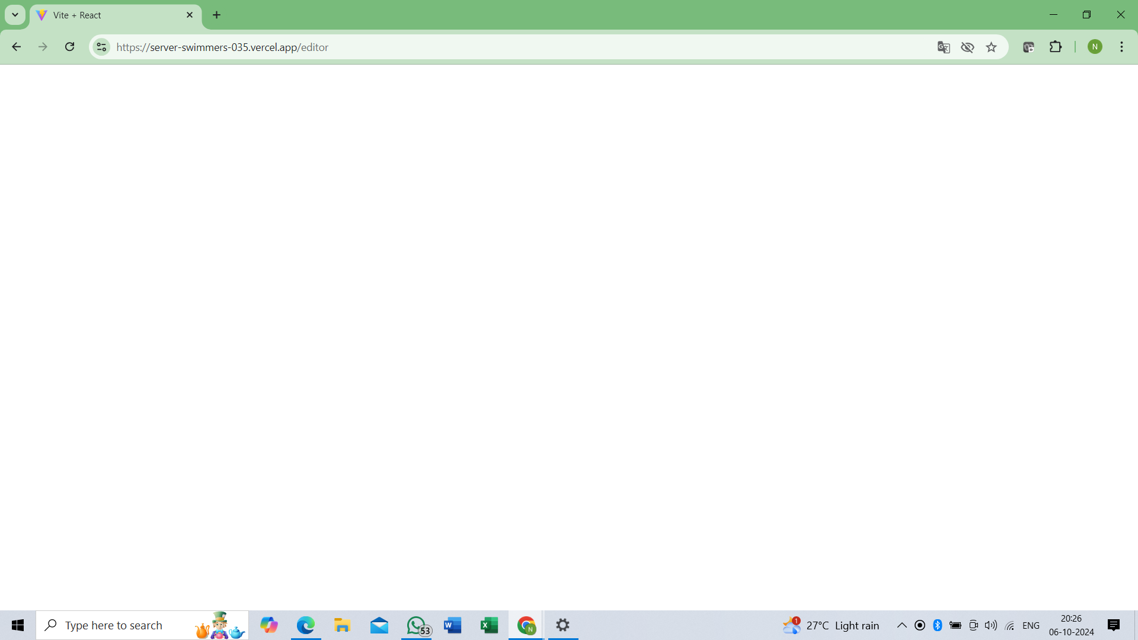

**B_002:**

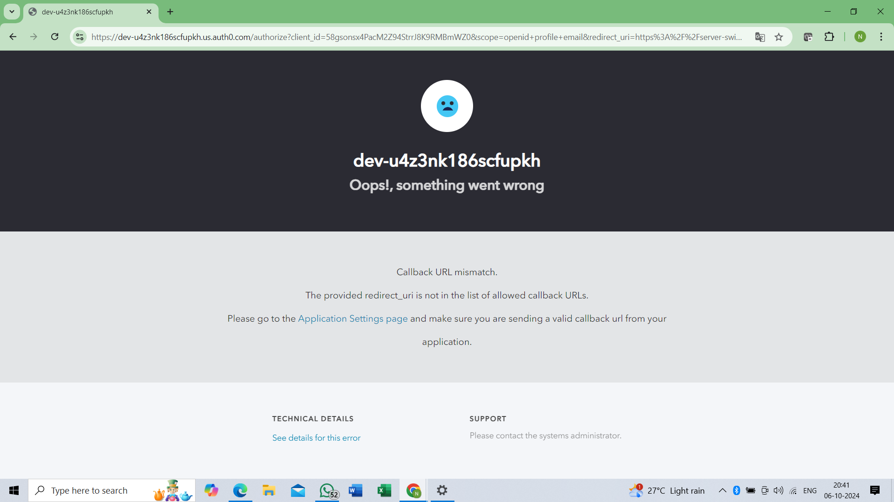

**B_003:**

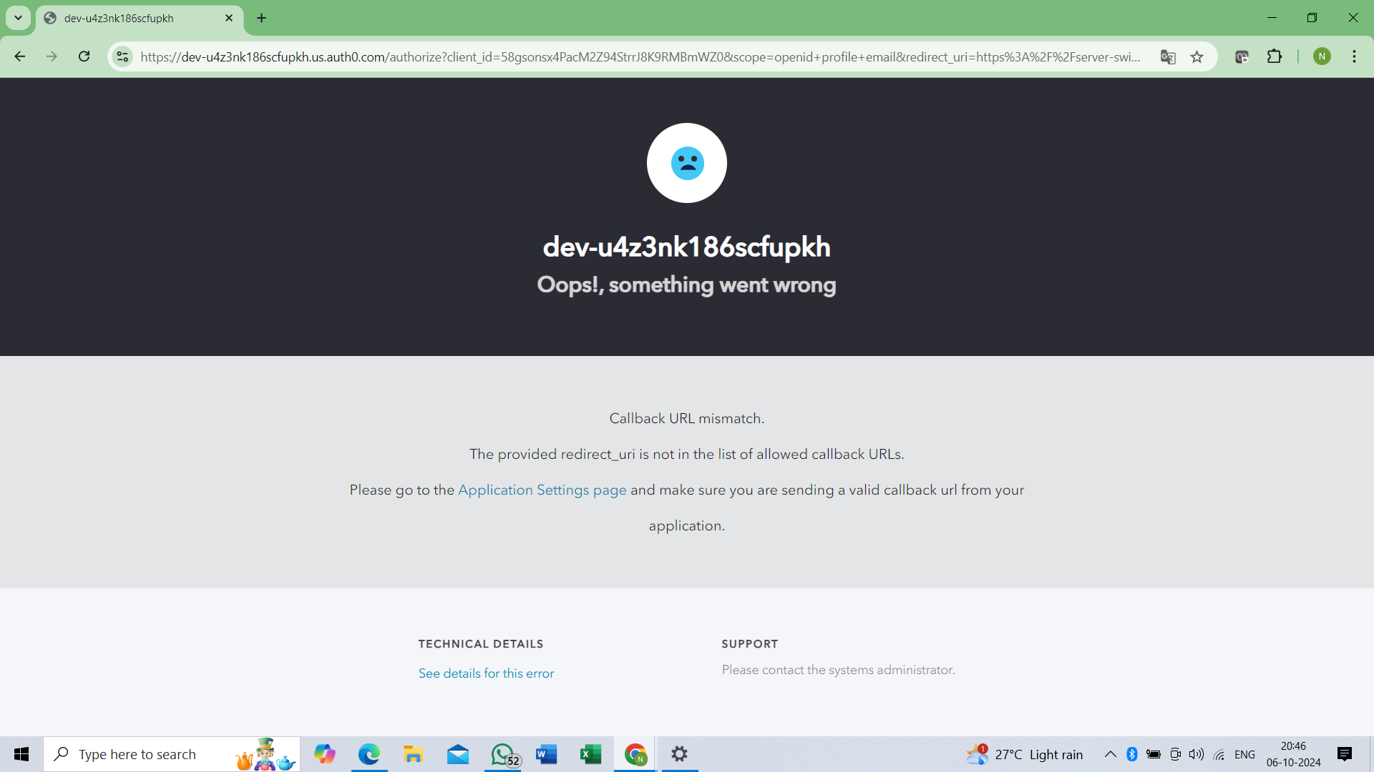

**B_004:**

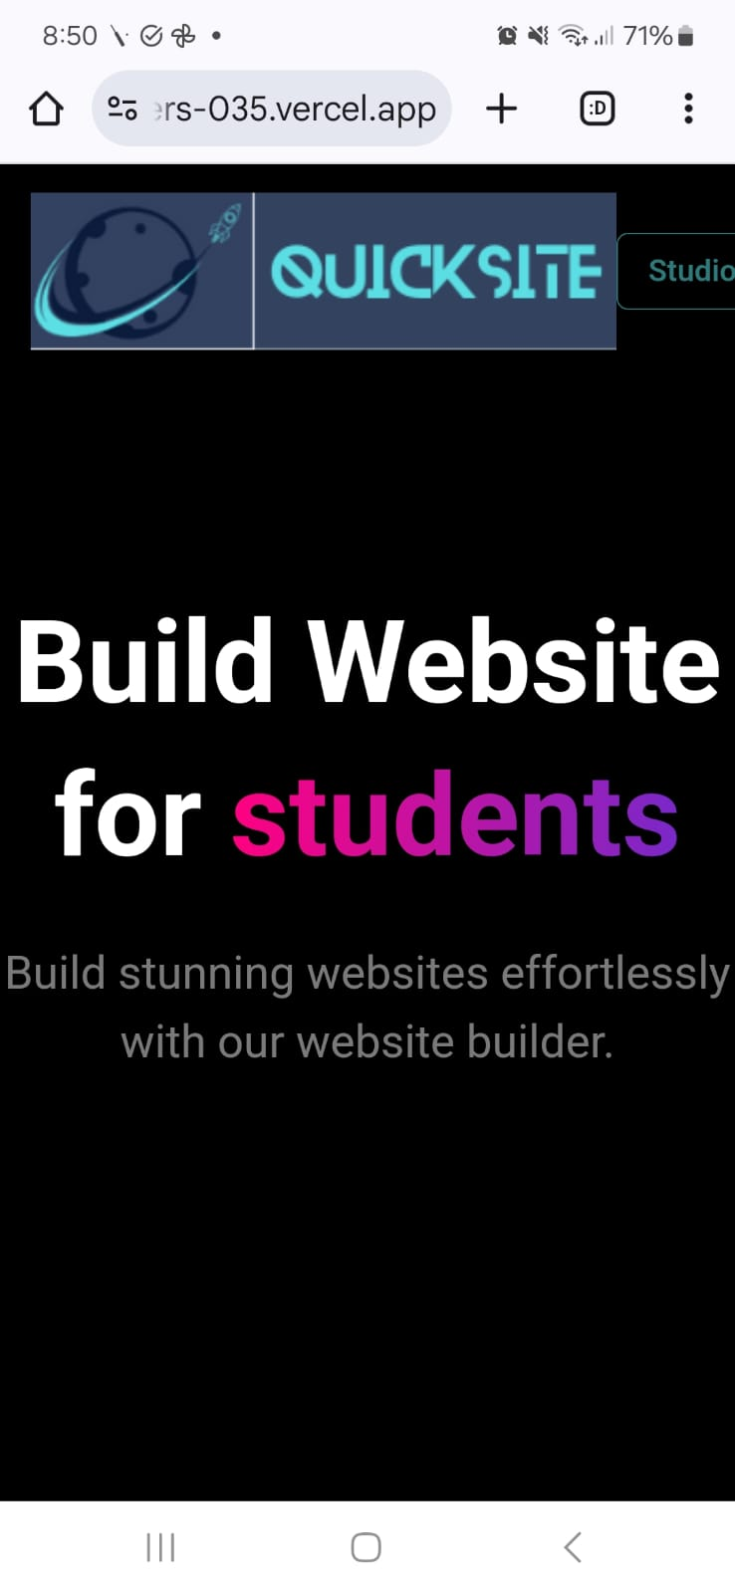

**B_005:**

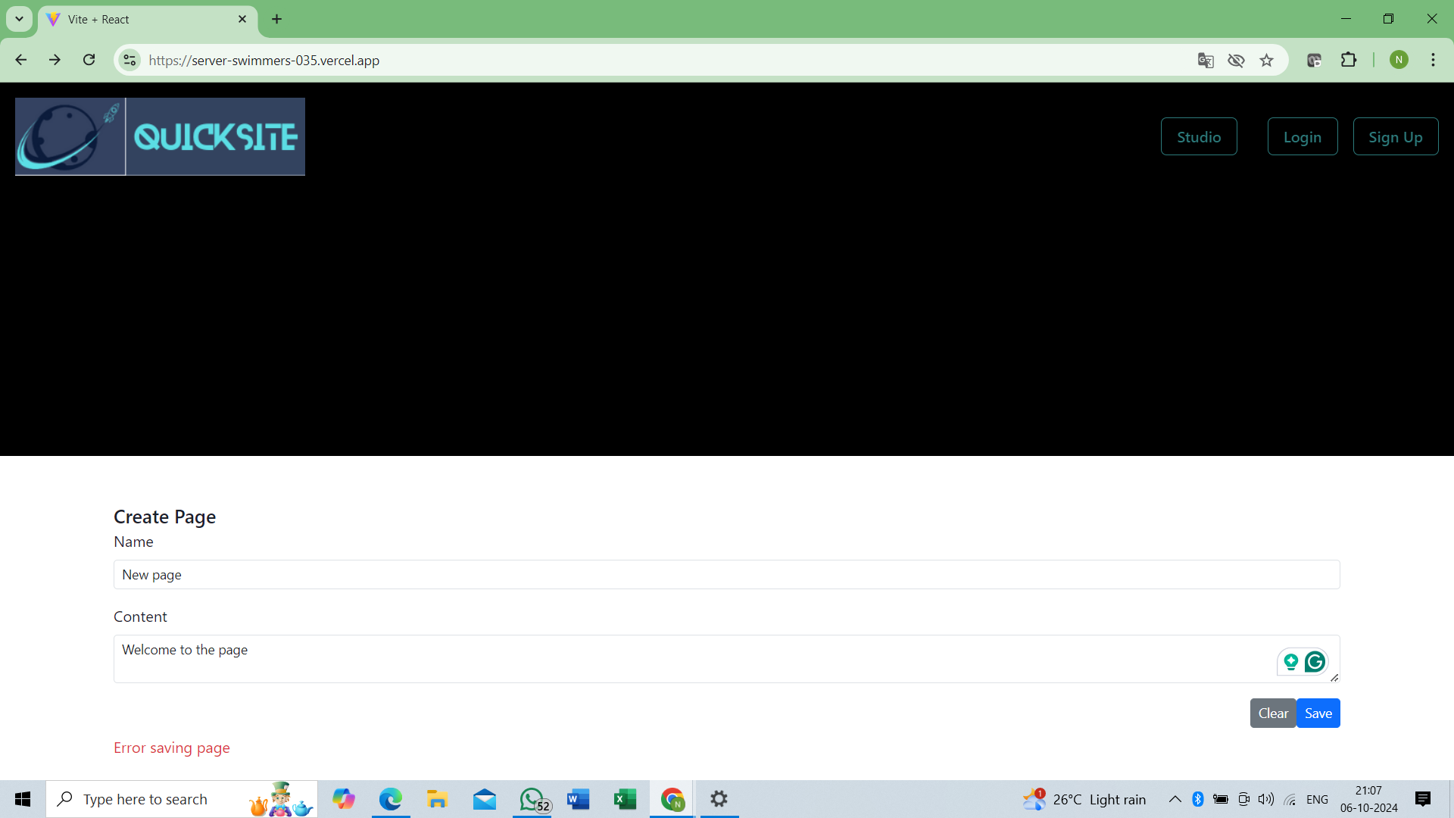

**B_006:**

